Guidelines for Obtaining a Freight Rate

- Select any origin and destination
- Select mode of transportation
- Select commodity
- Enter weight and measure
- Select service type
To view container specifications and conversion tables click on the link:
Weight, Volume, and Linear Measure conversion tables

Intermodal Transportation.
This is a combination of modes transportation and types of services needed to complete an origin-destination freight-rate-calculation.

Find below the international methodology for calculating freight rates for different modes of transportation.

The IATA / Airline Cubic Allowance Factor for Air Freight Shipments:
Rate calculation has an allowance of 6,000 Cubic Centimeters per 1 Kilo. The illustration below shows how to calculate the dimensional chargeable weight as follows:
Air (IATA) shipment weight measured in kilos
(6,000 cm³)= 1 Kilo
45 x 30 x 65=87,750 cm³/6,000 = 14.625 MMK
MMK= Measured Metric Kilos
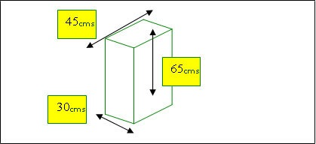
Standard Road Haulage Allowance Factor for Road Freight (RHA)
Rate calculation has an allowance of 3 Cubic Meters per 1,000 Kilos. This illustration below shows you how to calculate the Volumetric Chargeable Weight as follows:
(RHA-Road Haulage Allowance). (DITTO) for Rail
3 Cubic Meters per 1 Metric Ton-- Equivalent
TO (3,000,000 cm³= 1 Metric Ton)
100 X 120 X 150= 1,800,000 cm³/3,000,000= 0.6 MMT
MMT= Measured Metric Tons
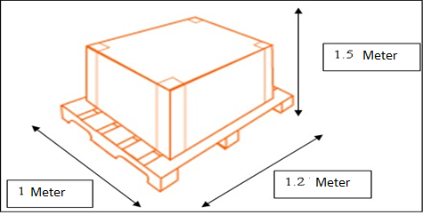

Standard Maritime Allowance Factor for Ocean LCL Group Freight
Rate calculation has an allowance of 1 Cubic Meter per 1,000 Kilos. This illustration below shows you how to calculate the Volumetric Chargeable Weight as follows: (Based on the IMC standard)
Ocean shipment weight measured in Metric Tons
( 1,000,000 cm³= 1 Metric Ton)
100 X 120 X 150=1,800,000 cm³/1,000,000= 1.8 MMT
MMT= Measured Metric Tons
ISO-Modular Carton (IMC) program is a corrugated box footprint strategy designed to "module" standard ISO-Sea Containers. This strategy is required to maximize freight and quality while eliminating non-value added handling and crating.
OCEAN CONTAINERS ISO 668:2013 Series 1 freight containers—Classification, dimensions and ratings
 | 20′ container | 40′ container | 40′ high-cube container | 45′ high-cube container
 | metric | metric | metric | metric
internal volume | 33.1 m³ | 67.5 m³ | 75.3 m³ | 86.1 m³
empty weight | 2,200 kg | 3,800 kg | 3,900 kg | 4,800 kg
net load | 28,200 kg | 26,600 kg | 26,580 kg | 25,600 kg

